Pennsylvania American Legion
Housing for Homeless Veterans Corporation

ANNUAL FUND RAISING DINNER

Saturday, January 18, 2020 Ads for Program Book
DoubleTree Pittsburgh Airport Full Page $75
8402 University Blvd., Moon Township, PA ½ Page $55
5:30 PM - Cash Bar 7:00 PM - Dinner

Cost: $30.00/person

(Please include payment with dinner ticket and/or ad order)

Mail check (payable to PA American Legion Housing for Homeless) to:
Ron Conley
709 Hope Street
Pittsburgh, PA 15220
TOUCHING
THE LIVES
OF
HOMELESS
VETERANS
TOUCHING
THE LIVES
OF
HOMELESS
VETERANS
(412) 726-3982

Deadline for ads: December 27, 2019

Deadline for dinner tickets: January 10, 2020

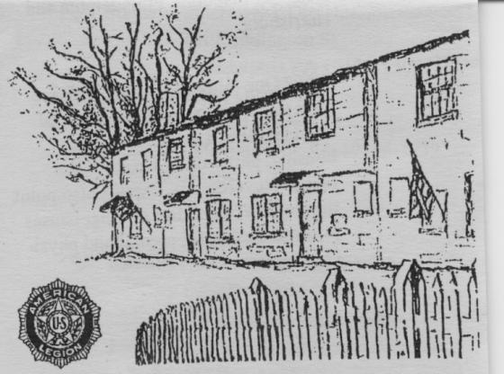

The official registration and financial information of Pennsylvania American Legion Housing for Homeless Veterans Corp. may be obtained from the Department of State by calling toll-free within Pennsylvania 1-800-732-0999.
Registration does not imply endorsement.

NAME___________________________________________________________________________

ADDRESS________________________________________________________________________

CITY/STATE/ZIP___________________________________________________________________

# OF TICKETS_____________ SIZE OF AD______________________

POST_____________ UNIT_____________ DISTRICT_____________ OTHER__________

AMOUNT ENCLOSED_______________

(PLEASE NOTE THAT ALL TICKETS WILL BE MAILED TO THE ABOVE LISTED ADDRESS)

