The American Legion
Department of Pennsylvania
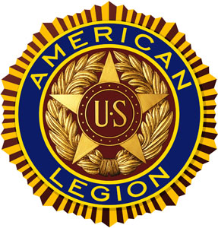
“Buy a Brick”

Please help the Pennsylvania American Legion headquarters by
purchasing and engraving a brick. SAL and Auxiliary members are also welcome to purchase bricks. Bricks will be placed in the new “side courtyard” area outside of Department Headquarters. The side courtyard will include a fountain, benches, flowers, and these engraved pavers and will be known as the Bubbling Water Memorial. All extra proceeds will be donated to American Legion programs.
REQUESTS FOR ENGRAVED BRICKS
NOW THRU JANUARY’S DEC------NO EXCEPTIONS!!!
_____ 4” x 8” $50 3 lines of engraving up to 15 characters
per line, spaces, numbers and letters

THERE ARE 350 BRICKS AVAILABLE.
FIRST COME, FIRST SERVED BASIS.
Purchased by___________________________________________________________________
Address_______________________________________________________________________
City_______________________________________State____________Zip________________
Phone_____________________________Email_______________________________________
Engraving: PLEASE PRINT LEGIBLY - ALL ENGRAVING SUBJECT TO APPROVAL
Line 1

Line 2

Line 3

Line 4

Line 5

Questions should be directed to Dean Fetters at 717-545-5116.
Please make check payable to: American Legion Riders Chapter 730
Return to: Charles Oakley, Legion Riders Chapter 730, 1082 Acri Drive, Harrisburg, PA 17111
Will be placed in ground in the spring.

